Request for proposals
New Philadelphia
South Broadway Traffic Study


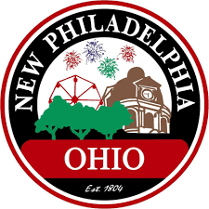
Issue Date: June 1, 2026
Deadline to Submit: June 15, 2026

Ohio Mid-Eastern Governments Association
1776 Tech Park Drive NE, Suite 221
New Philadelphia, OH 44663
Home - OMEGA (omegadistrict.org)

SECTION 1: Basics of the Request for Proposal

PROJECT DESCRIPTION

The Ohio Mid-Eastern Governments Association (OMEGA) is requesting Cost Proposals for a traffic projection study for the South Broadway corridor in New Philadelphia, Tuscarawas County, Ohio. Funding for this project is from the Technical Assistance program through the state’s Appalachian Community Grant Program (ACGP) under the Ohio Department of Development. The selected firm will develop a study examining the multimodal traffic operations and safety impact of new residential and commercial along S Broadway in Downtown New Philadelphia. Time of performance is critical because all work on this project must be completed by September 30, 2026.

PROCURING AND CONTRACTING AGENCY

This Request for Proposals (RFP) is being issued by the Ohio Mid-Eastern Governments Association (OMEGA). The person responsible for managing the procurement process is

Ben Turin
Transportation Manager
bturin@omegadistrict.org

SCOPE OF WORK

Proposals will need to include the following items in the Scope of Work as well as the CONSULTANT’s approach to completion of these work activities.
The S Broadway corridor connects the south side of the City of New Philadelphia to US-250, the downtown area, and all other areas of town. It is the only major thoroughfare for residents, customers, and other visitors to reach this neighborhood of the City and thus already faces congestion throughout the day. A new development with several hundred housing units as well as new commercial retail space is being developed on the Joy Development Site, also known as the Howden-Buffalo Property. The City anticipates congestion to worsen with an influx of new residents and retail activity along S Broadway. Additionally, the southernmost trailhead of the Ohio & Erie Canal Towpath Trail is being built over the next two years (ODOT PID# 124728) at Waterworks Park which is adjacent to the Joy Development on its south side. Finally, the Downtown New Philadelphia Quadrant Redesign Project will be complete by September 30th at the intersection of S Broadway and High Avenue, bring more retail, events, and pedestrian activity to downtown New Philadelphia.
All of this development is expected to bring increased traffic to and through downtown New Philadelphia of not only cars but trucks, cyclists, and pedestrians. Therefore, the City of New Philadelphia would like to have a traffic study completed to forecast the growth across all modes of travel along the S Broadway Corridor and into the downtown core to proactively prepare for the congestion and traffic safety conflicts. Other nodes of activity that contribute to traffic along S Broadway should be included in the analysis, including:
- Bluebell Drive/I-77 Interchange area
- South Elementary School
- Roswell Trailhead
- US-250 interchange with S Broadway and Commercial Avenue

The study should address, at a minimum,
- Existing traffic patterns and operations,
- Forecasted traffic levels for vehicular traffic, walking, and biking,
- Improvements to traffic operations along the corridor,
- Connections between Waterworks Park and the Roswell Trailhead, and
- Recommendations to improve safety within and between modes of travel.
The selected Consultant will have access to prior studies and plans that have been completed in and around the City of New Philadelphia and its downtown.
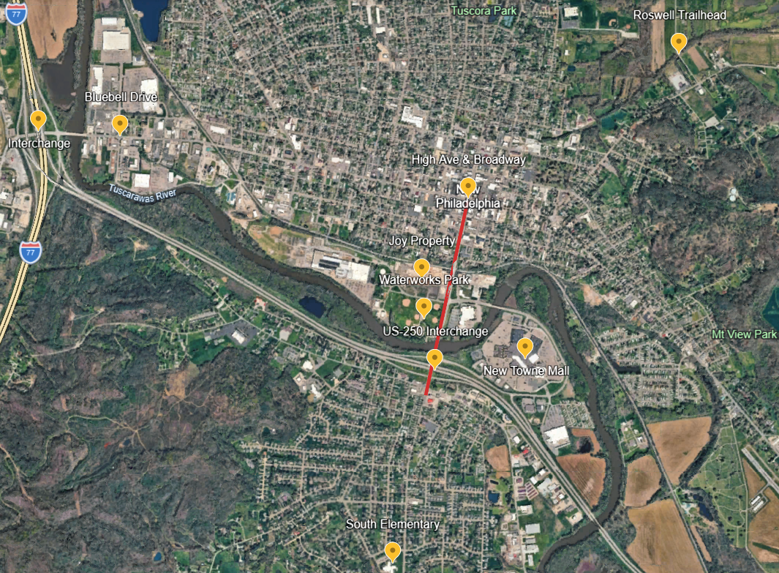
Project Area: S Broadway marked in red; Key points of interest to the study marked with yellow pins

SUBMISSION REQUIREMENTS

Proposals should be limited to no more than 20 pages and include, but not limited to, the following:

- Qualifications
- Brief history of firm
  - Approach
  - Experience with similar projects
  - Experience working with and/or in <County Name>
  - Primary Point of Contact
  - Project Team Qualifications and Availability
  - Resumes of Key Project Personnel
  - Minimum of three Professional References with contact name, phone number, e-mail address and brief description of work performed
  - Cost Proposal
  - Projected Timeline of Performance

- Qualifications, Experience, and Capabilities. Describe the qualifications and capabilities for the analysis, deliverables, and project management for similar projects. Provide qualifications of any anticipated subconsultants that will be needed to complete all relevant components of the project. Include project summaries of relevant projects completed.

- Approach. Describe approach to defining analyzing current traffic conditions, forecasting traffic patterns, and developing recommendations for multimodal safety and congestion issues.

- Key Staff Assigned to Project. Include resumes of key staff assigned to this project and provide an organization chart identifying personnel assigned to this project, including their roles, anticipated level of involvement, and availability. Personnel identified in the proposal must be the principal staff that will work with OMEGA and the City of New Philadelphia and represent the majority of hours billed.

- Company History. Provide overview of company including but not limited to:

- Legal name of business
- Identification of parent companies, subsidiaries, and affiliates
- Years in business
- State of formation
- Number of employees
- Licenses and certifications relevant to the described work
- Cost and Time of Performance. Provide an estimated cost to a traffic projection study for the South Broadway corridor with all components described in Section 1.3 – Scope of Work.

QUESTIONS AND CLARIFICATIONS

Any questions concerning this RFP may be submitted to:

Ben Turin
Transportation Manager
bturin@omegadistrict.org

Entities are expected to raise any questions, exceptions, or additions they have concerning the RFP document or its requirements at this point in the RFP process. If an entity discovers any significant ambiguity, error, conflict, discrepancy, omission or other deficiency in this RFP, the entity should immediately notify OMEGA.

1.5 SCHEDULE

All proposals are due by 2:00 PM on Monday, June 15 by e-mail only to:

Ben Turin
Transportation Manager
bturin@omegadistrict.org

Late submittals will not be accepted. OMEGA and New Philadelphia may conduct interviews of short-listed firms and anticipates making a selection by June 25, 2026.

SECTION 2: Proposal Procedure & Entity Information

2.1 GENERAL INSTRUCTIONS AND INFORMATION

The evaluation and selection of the Firm will be based on the information submitted in the entity’s proposal, approach, and creativity. Failure to respond to each of the requirements in the RFP may be the basis for rejecting a response. Entities should respond clearly and completely on all requirements.

2.2 DEVIATION AND EXCEPTIONS

Deviations and exceptions from terms, conditions, or specifications from this RFP shall be described fully on the entity’s letterhead, signed, and attached to the response. In the absence of such statement, the proposal shall be accepted as in strict compliance with all terms, conditions, and specifications and the entity shall be held liable.

2.3 AFFECTIVITY OF OTHER MEDIA

This RFP is the official media governing proposal procedures. No other documents, letters, or oral instructions shall have any influence whatsoever, unless incorporated by reference herein, or unless an official AMENDMENT is made to this document by OMEGA.

SECTION 3: Proposal Evaluation & Acceptance

3.1 EVALUATION AND SELECTION

All qualified proposals submitted in accordance with the terms of the RFP will be evaluated to determine the most responsive entity. A uniform selection process will be used to evaluate all proposals. Representatives from the OMEGA and the City of New Philadelphia will review and score the proposals.

3.2 SELECTION CRITERIA

Proposals will be evaluated and ranked based on the selection criteria outlined below. OMEGA may ask the top ranked firms, groups, or persons to interview as part of the evaluation process. After the conclusion of the evaluation process, the firms, groups, or persons will be ranked in priority order with the highest-ranking firm, group, or person being selected to negotiate a contract and scope of services with OMEGA.

In the event OMEGA elects to negotiate a contract with a selected firm, group, or person, OMEGA reserves the right to negotiate such terms and conditions of the contract, including, but not limited to scope, role, price, and staffing which may be in the best interests of OMEGA.

OMEGA and the City will evaluate proposals based upon the following criteria:

- Proposed approach
- Background and experience with similar projects
- Capacity to perform work
- Proposed Cost of Services
- Proposed Time of Performance
- Relevant experience of Project Team
- Familiarity with local area, geography and facilities
- Work experience in Tuscarawas County

3.3 RIGHTS RESERVED

OMEGA reserves the right, in its sole discretion, to reject all submissions, reissue a subsequent RFP, terminate, restructure, or amend this procurement process at any time. Evaluation criteria contained herein shall be used in evaluating interested firms, groups, or persons for selection. OMEGA may contact any RFP respondent after receiving its submittal to seek clarification on any portion thereof. OMEGA reserves the right to request additional information from any RFP respondent if OMEGA deems such information necessary to further evaluate selection. OMEGA reserves the right to select several consultants to perform tasks under the contract. All RFP material submitted to OMEGA becomes property of OMEGA and will not be returned to the RFP respondent.

