RTPO Allocation Program Application Instructions

The Ohio Mid-Eastern Governments Association (OMEGA) is currently accepting applications for the OMEGA RTPO Capital Program. Eligible applicants must be a public agency within an OMEGA RTPO County (Carroll, Columbiana, Coshocton, Guernsey, Harrison, Holmes, Muskingum, or Tuscarawas) that is legally allowed to enter into a contract with ODOT. Non-profit organizations, school districts, and other non-public organizations are not eligible applicants, but they may coordinate/partner with an eligible applicant. The sponsoring agency assumes responsibility for project execution and completion. The sponsoring agency must own, hold an easement, or acquire the land on which the project is located. Specific details about this program are provided in the OMEGA RTPO Allocation Program Policy.

Funding from OMEGA RTPO Allocation Program can be used for planning, preliminary engineering, detailed design, environmental, right-of-way services, construction, and construction engineering. Please note that funds from the OMEGA RTPO Allocation Program cannot be used to match other federal funds. For example, if a city has received funding for construction under the Small Cities Program, funds from the OMEGA RTPO Allocation program cannot be used as a match for construction or construction engineering. However, funds from this program can be used for non-construction costs such as planning, preliminary engineering, detailed design, environmental, or right-of-way services if no other federal funds are used for these phases.

Eligibility:

- Applicants MUST be a public agency within an OMEGA RTPO County that is legally allowed to enter into a contract with ODOT.
- Project must be on a Federal Aid Route (Exceptions are Bridges, Safety and Bicycle/Pedestrian Projects)
- Bridges must have a span of at least 20 feet.
- Project must be in one of the plans listed in the OMEGA RTPO Allocation Program Policy
- Nonprofit organizations, school districts, and other non-public organizations are not eligible.

Required Attachments:

- Signed and Sealed Certified Engineer’s Cost Estimate for construction projects only
- Project Location Map
- Project Schedule by Phase
- Resolution (example provided in Attachment A)
- Documentation on matching funding from local, state, and/or federal sources (such as grant agreement or letter of award notification, or local share letter (example provided in Attachment B) signed by applicant’s chief financial officer)
- Other Documentation to support application, such as photos or letters of support

Maximum Grant:

- $50,000 for project-specific planning
- $150,000 for regional planning initiatives
- $400,000 for all other projects (preliminary engineering, detailed design, environmental, or right-of-way services, construction, and construction engineering) not to exceed 50% of the total project cost for all phases

Questions:

For any questions, further information, or if general appraisal/crash analysis are required, please contact Erin Wright, OMEGA Director of Infrastructure & Community Development at ewright@omegadistrict.org or (330) – 243-0133.

Deadline:

Submit the OMEGA RTPO Allocation Application with attachments, by 4:00 pm on August 31, 2024 to: ewright@omegadistrict.org (preferred), or mail copies to:

Ohio Mid-Eastern Governments Association
326 Highland Avenue
Cambridge, Ohio 43725
Attn: Erin Wright

The application is a fillable pdf document designed to automatically calculate the points to be awarded, up to a maximum of 80 points. Specific scoring criteria are provided in Attachment C.

All applicants are required to complete Section 1.0 General Information and depending upon project type, complete only one of the following sections.

- Section 2 Road and Bridge Projects
- Section 3 Safety Projects
- Section 4 Bicycle Pedestrian Projects

Since the application is designed to automatically calculate the total number of points, the applicant may complete multiple sections prior to submission of the application to see which project type may receive the highest number of points. Safety projects are the most heavily weighted. If unsure which section best fits your project, please contact Josh Sliker.

Section 1.0 General Information (40 points)
All applicants must complete this section and provide relevant details about the project.

Basic Information: Provide project title, ODOT PID No. (if applicable), name of applicant, contact information for applicant (person most familiar with project), contact information for engineering firm or city/county engineer.

Project Type: Check which project type is most applicable. If your project does not fit one of these categories, please check “other” and specify project type.

Project Phase: Check all phases for which funds from this program are being requested. For example, if an applicant has received a Transportation Alternative Program grant from ODOT for construction of a bicycle/pedestrian multi-use path, the applicant may apply to this program for funding for preliminary engineering, detailed design, environmental, and right-of-way services and would check all four of those boxes.

Location: Examples include CR 6 SLM 5.5 to SLM 7.0 or Main Street from First Avenue to Fifth Avenue.

Project Planning: Check which planning document applies. Please note that with the exception of School Travel Plans, all documents listed are on OMEGA’s website, https://omegadistrict.org

- OMEGA Long Range Transportation and Development Plan 2020 to 2040 https://omegadistrict.org/programs/transportation/plan2020/
- OMEGA Regional Transportation Improvement Plan 2024 to 2027: https://omegadistrict.org/programs/transportation/rtip/
- OMEGA Regional Roadway Safety Plan: https://omegadistrict.org/safety/
- OMEGA Tri-County Active Transportation Plan: https://omegadistrict.org/tri-county/

Median Household Income (MHI): The average median household income (MHI) for the OMEGA RTPO region based upon the 2017-2021 5-year ACS data is $54,571. Please use the MHI data for the county or political subdivision that is most appropriate for the project.

Purpose & Need: In 500 words or less, provide the purpose and need for the project such as

“The purpose of this project is to provide safe pedestrian access for residents of the city. Pedestrian infrastructure currently does not support access to and from residences (especially low income and elderly housing), local businesses, medical facilities, and public facilities such as parks. Sidewalks do not exist in the project area and residents are forced to either walk in the roadway or along the berm. Pedestrian safety is a major concern as there have been two pedestrian/car crashes in the last three years. Increased accessibility and safer travel for pedestrians and motorized wheelchairs are needed. A renewed sense of freedom and independence is expressed from the physically disabled community by being able to travel safely without the need for an aide or vehicle.”

Project Description: In 750 words or less, provide a detailed project description such as

“The project will extend 2,000 linear feet of new 6-foot-wide sidewalks along First Avenue from Elm Street to Pine Street. This new sidewalk will connect residents from a low-income housing complex and senior housing to local businesses, banks, the post office, the local office of Jobs and Family Services, medical offices, and the city park. ADA compliant curb ramps and crosswalks will be provided at the intersections in the project area. There is one signalized intersection in the project area and pedestrian signals will be added. All work will be conducted within the existing right-of-way. The City has received TAP funding from ODOT for this project and will be requesting funds from the OMEGA RTPO Allocation program for preliminary engineering and detailed design. Construction is anticipated to begin in 2025.”

Project Costs: Please list the funds requested by phase as well as the other federal, state, and local funds by phase that are committed to the project as well as the year that the OMEGA RTPO Capital Allocation Funds will be needed. Using an ODOT TAP funded project as an example, this table would be completed as follows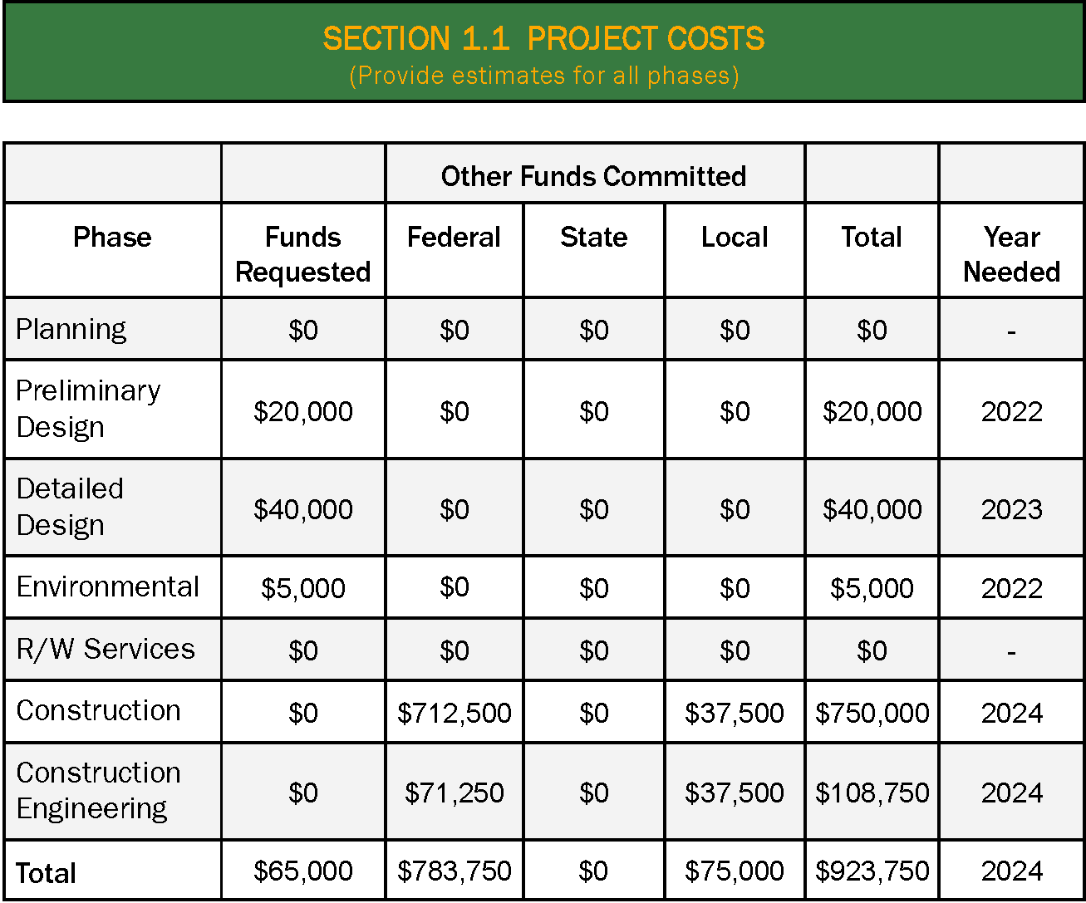

Depending upon project type, complete Section 2.0, 3.0 or 4.0. Complete only one section of these sections.

Section 2.0 Road and Bridge Projects (40 points)
Functional Class: Project must be on a federal-aid route. Local roads and rural minor collectors are not eligible for this program.

Average Daily Traffic (ADT): Data may be available through TIMS (https://gis.dot.state.oh.us/tims) or OMEGA.

For Road Projects, please list EITHER the number of years since last improved such as 13 years, (not the year it was improved, ie. 2010) OR the Pavement Condition Rating (which may be available from the county engineer).

For Bridges Only, please list the General Appraisal available through TIMS (https://gis.dot.state.oh.us/tims), the span such as 20 feet, and any weight restrictions in effect.
Section 3.0 Safety Projects (40 points)
If your project addresses a specific safety issue, please complete this section. OMEGA will provide crash analysis data if not available. Please note that if the scope of the project includes roadway rehabilitation on a road with a high number of crashes and includes countermeasures to reduce the number of crashes, then this section should be completed. However, if countermeasures to reduce the number of crashes are not included in the project scope, then Section 2.0 should be completed.

The Equivalent Property Damage Only (EPDO) will be automatically calculated. For reference, the EPDO is calculated using the following formula:

EPDO = (KA x 39.24 + B x 6.55 + C x 4.44 + O x 1.0)/N

Where, KA = Number of Fatal and Serious Injury Crashes
B = Number of Visible Injury Crashes
C = Number of Possible (non-visible) Injury Crashes
O = Number of Property Damage Only Crashes
N = Total Number of Crashes

OMEGA Regional Roadway Safety Plan Hot Spot Rankings (1 to 50 per county) or OMEGA Regional Roadway Safety Plan Systemic Rankings (1 to 5 per county) are listed in the OMEGA Regional Roadway Safety Plan: https://omegadistrict.org/safety/

Section 4.0 Bicycle/Pedestrian Projects (40 points)
Population Served: Please list the population that will be served by this project. For example, new sidewalks in a downtown business district will serve the entire population of the village or city; whereas, sidewalks in a residential area would only serve that neighborhood.

Specify Sidewalk or Multi-Use Path/Trail

Specify New or Repair/Replacement: For example, a multi-use path or buggy lane along an existing road would be viewed as repair/replacement.

Connectivity: Please check all that apply

Attachment A

Example Ordinance

Attachment B

Example Local Share Letter

Attachment C

Scoring Criteria

